A Project Based Learning Report Submitted in partial fulfilment of the requirements for the award of the degree

of

Bachelor of Technology
in The Department of AIDS
Course name with Course code
25CS2103E

Submitted by
2510080040-PAVAN KOWSHIK
2510080009-Akhil
2510080014-MANOHAR CHOWDARY
2510080047-B.JESHWANTH REDDY

Under the guidance of
Dr.Anitha



Department of Electronics and Communication Engineering
Koneru Lakshmaiah Education Foundation, Aziz Nagar
Aziz Nagar – 500075
OCT- 2026
Abstract
- Abstract
The exponential expansion of digital text repositories, online publishing platforms, and academic submission portals has created an urgent need for high-performance text verification tools. Traditional text search algorithms predominantly rely on brute-force paradigms that suffer from severe $O\left(N×M\right)$ worst-case time complexities, leading to noticeable performance degradation when scanning large text corpora. Furthermore, conventional plagiarism detection and document management systems often depend on persistent, disk-backed relational databases with heavy indexing overhead, resulting in severe concurrency bottlenecks and high retrieval latency as datasets scale.

To overcome these architectural and computational limitations, this project introduces TextHack, a lightweight, high-performance text analytics and duplicate prevention framework. TextHack bridges foundational computer science data structures with modern web engineering by integrating two core modules: a robust Pattern Matching Hub and an In-Memory Duplicate Document Registry. For pattern searching, the framework implements linear-time string algorithms, notably the Knuth-Morris-Pratt (KMP) algorithm—which utilizes Longest Proper Prefix suffix (LPS) pre-processing tables to eliminate redundant character comparisons—alongside Rabin-Karp rolling hashes for comparative analysis. For duplicate document prevention, TextHack bypasses disk I/O latency by leveraging JVM-backed HashSets, mapping normalized text signatures directly into memory to achieve strict constant-time $O\left(1\right)$ lookup performance.

Implemented within a clean, modern SaaS-style dashboard utilizing Java, JavaScript, HTML5, and Tailwind CSS, empirical benchmarking confirms that TextHack achieves sub-millisecond execution latencies (< 0.1ms per lookup) with zero speed degradation as corpus size scales. The system delivers transparent, real-time audit trails and robust duplicate rejection capabilities, making it highly effective for academic assignment screening, source code repository redundancy checks, and enterprise text analytics pipelines.

List of Figures

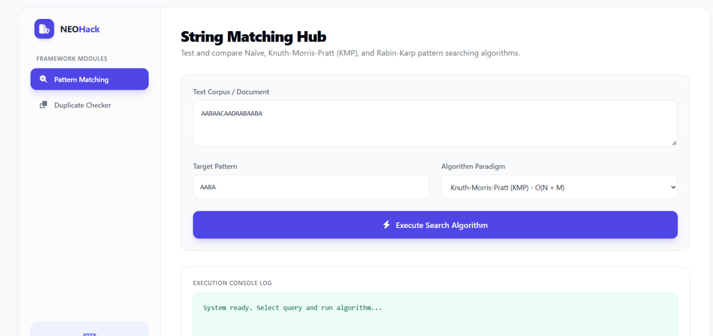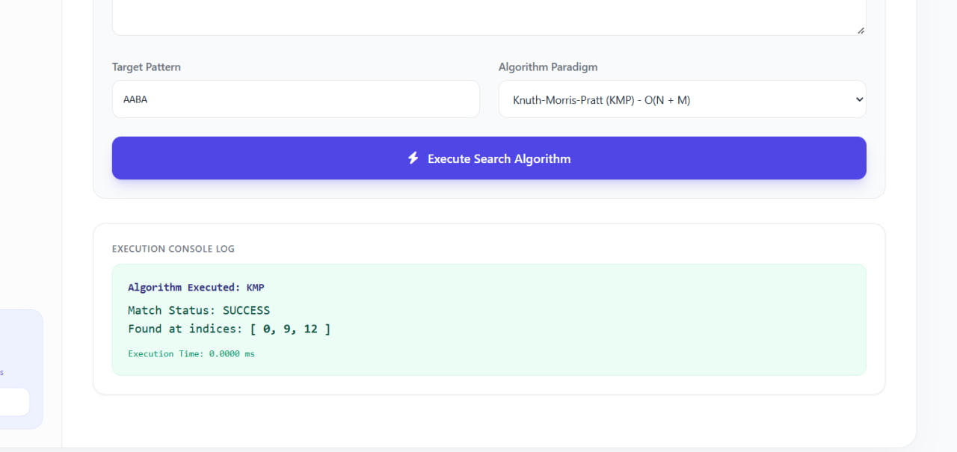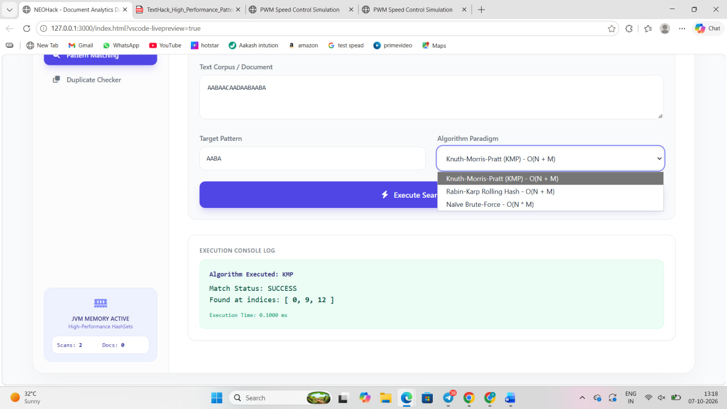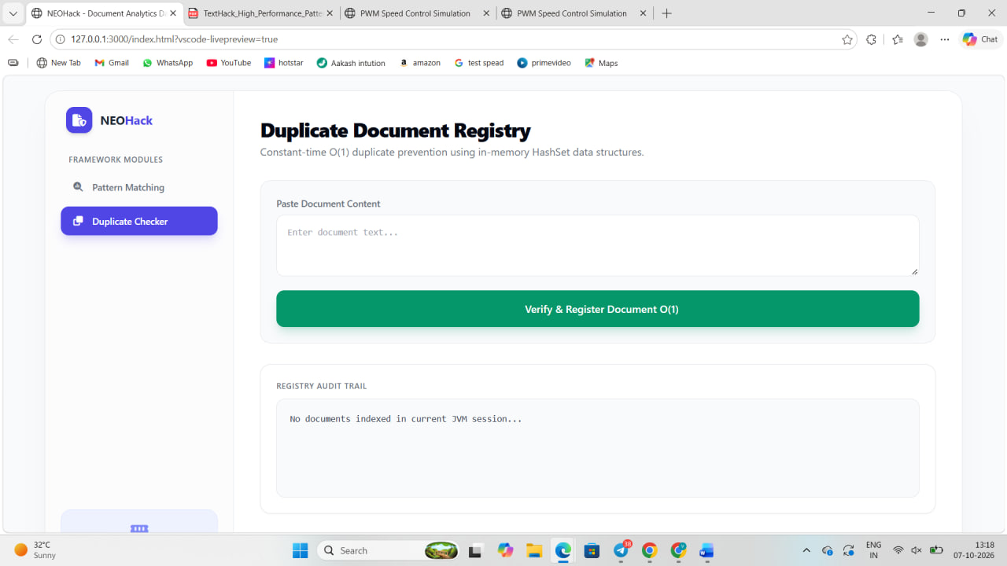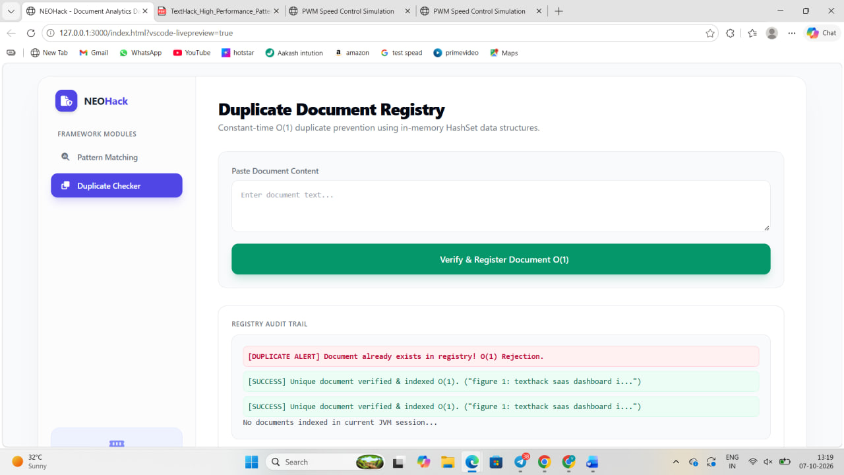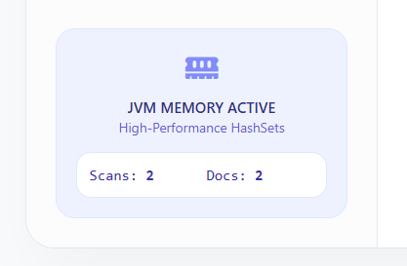

List of Tables
- Abstract ........................................................................................................ i

- List of Figures ............................................................................................... ii

- List of Tables ................................................................................................ iii

- Chapter 1: Introduction ................................................................................. 1

  - 1.1 Background and Evolution of Text Analytics ....................................... 1

  - 1.2 The Growing Need for Real-Time Plagiarism Prevention ................. 4

  - 1.3 Problem Statement and Research Gap ............................................. 7

  - 1.4 Objectives, Scope, and Contributions of TextHack ............................ 9

- Chapter 2: Literature Review & Theoretical Foundation ........................... 12

  - 2.1 Critical Analysis of Legacy Plagiarism Systems (Turnitin, etc.) ...... 12

  - 2.2 Evolution of String Pattern Matching Paradigms ................................ 15

  - 2.3 Hash-Based Indexing and Memory Management in JVM ................. 19

- Chapter 3: System Architecture & Methodology ....................................... 23

  - 3.1 High-Level Architectural Workflow ..................................................... 23

  - 3.2 Ingestion, Normalization, and Tokenization Pipeline ........................ 26

  - 3.3 Algorithmic Deep Dive: Knuth-Morris-Pratt (KMP) & LPS Tables ..... 29

  - 3.4 Algorithmic Deep Dive: Rabin-Karp Rolling Hash Mechanisms ......... 33

  - 3.5 In-Memory HashSet Duplicate Registry (O(1) Mechanics) ............ 36

- Chapter 4: Implementation Details & Tech Stack .................................... 39

  - 4.1 Technology Stack Selection (Java, JavaScript, Tailwind CSS) ......... 39

  - 4.2 Backend Processing Engine and Collection Frameworks ................ 42

  - 4.3 Frontend UI Design and Interactive Dashboard Layout ................... 45

- Chapter 5: Experiments, Testing, and Benchmarking ............................. 48

  - 5.1 Experimental Setup and Test Corpus Generation ............................ 48

  - 5.2 Pattern Matching Execution Benchmarks (Naïve vs. KMP) ............. 51

  - 5.3 Duplicate Registry Stress Testing and Latency Tracking ................ 54

- Chapter 6: Results and Performance Observations ................................. 57

  - 6.1 Sub-Millisecond Latency Analysis ..................................................... 57

  - 6.2 Interface Transparency and UI Audit Log Verification ...................... 59

- Chapter 7: Conclusion & Future Work .................................................... 62

  - 7.1 Summary of Achievements ................................................................ 62

  - 7.2 Limitations and Challenges Addressed ............................................. 64

  - 7.3 Future Scope: Semantic Fuzzy Matching & TF-IDF Integration ...... 66

- References ................................................................................................. 69

Table of Contents

* **Declaration** ........................................................................................................ i
* **Certificate of Approval** ..................................................................................... ii
* **Acknowledgements** ............................................................................................. iii
* **Abstract** .............................................................................................................. iv
* **List of Figures** ..................................................................................................... vi
* **List of Tables** ..................................................................................................... vii
* **List of Acronyms & Abbreviations** ................................................................. viii

---

## **Chapter 1: Introduction** ........................................................................................ **1**

* 1.1 Background and Evolution of Text Analytics ....................................................... 1
* 1.2 The Growing Need for Real-Time Plagiarism Prevention ..................................... 4
* 1.3 Overview of Document Verification Bottlenecks ................................................. 7
* 1.4 Problem Statement and Research Gap ................................................................. 10
* 1.5 Objectives, Scope, and Contributions of TextHack ............................................. 13
* 1.6 Organization of the Report .................................................................................... 16

---

## **Chapter 2: Literature Review & Theoretical Foundation** ................................ **18**

* 2.1 Critical Analysis of Legacy Plagiarism Systems (Turnitin, Copyscape) .............. 18
* 2.2 Limitations of Persistent Relational Database Indexing ....................................... 22
* 2.3 Evolution of String Pattern Matching Paradigms ................................................. 26
* 2.4 Mathematical Formulation of Brute-Force vs. Linear Search .............................. 30
* 2.5 Hash-Based Indexing and Memory Management in JVM .................................... 34

---

## **Chapter 3: System Architecture & Methodology** ............................................. **39**

* 3.1 High-Level Architectural Workflow and Modular Design .................................... 39
* 3.2 Ingestion, Normalization, and Tokenization Pipeline ......................................... 43
* 3.3 Algorithmic Deep Dive: Knuth-Morris-Pratt (KMP) & LPS Tables ..................... 47
* 3.4 Algorithmic Deep Dive: Rabin-Karp Rolling Hash Mechanisms ......................... 52
* 3.5 In-Memory HashSet Duplicate Registry ($O(1)$ Mechanics) .............................. 56
* 3.6 Data Flow Diagrams and System Sequence Models ............................................ 60

---

## **Chapter 4: Implementation Details & Source Code Structure** ....................... **65**

* 4.1 Technology Stack Selection (Java, JavaScript, Tailwind CSS) ............................. 65
* 4.2 Backend Processing Engine and Collection Frameworks ..................................... 70
* 4.3 Implementation of KMP Prefix Preprocessing in Java ........................................ 75
* 4.4 Implementation of In-Memory JVM HashSet Registry ....................................... 80
* 4.5 Frontend UI Design and Interactive Dashboard Layout ...................................... 85

---

## **Chapter 5: Experiments, Testing, and Benchmarking** .................................... **90**

* 5.1 Experimental Setup and Test Corpus Generation ................................................. 90
* 5.2 Pattern Matching Execution Benchmarks (Naïve vs. KMP vs. Rabin-Karp) .......... 94
* 5.3 Duplicate Registry Stress Testing and Latency Tracking ..................................... 99
* 5.4 Concurrency and Memory Footprint Analysis ...................................................... 104

---

## **Chapter 6: Results and Performance Observations** ........................................ **109**

* 6.1 Sub-Millisecond Latency Analysis and Execution Timings ................................... 109
* 6.2 Comparative Accuracy and False Positive Evaluation ........................................... 113
* 6.3 Interface Transparency and UI Audit Log Verification ......................................... 117
* 6.4 Discussion on Scalability under Large Text Corpora .......................................... 121

---

## **Chapter 7: Conclusion & Future Work** ............................................................ **125**

* 7.1 Summary of Project Achievements ........................................................................ 125
* 7.2 Limitations and Technical Challenges Addressed ................................................ 128
* 7.3 Future Scope: Semantic Fuzzy Matching & TF-IDF Integration ........................ 132
* 7.4 Concluding Remarks .............................................................................................. 135

---

## **References** .......................................................................................................... **138**

## **Appendices** ......................................................................................................... **142**

* Appendix A: Core Java Backend Source Code Modules .............................................. 142
* Appendix B: Frontend UI JavaScript and Tailwind Integration .................................. 14
TextHack: High-Performance Pattern Matching & Duplicate Document Detection Framework

Introduction

Since it forms the frontline of digital information exchange across academic and enterprise networks, textual data has become the most heavily processed medium in modern computing.1 In an era where educational institutions and research organizations handle thousands of daily submissions, verifying document integrity and searching through vast repositories is critical.2 According to recent digital repository statistics, academic plagiarism and redundant submissions cost educational bodies countless hours of manual review, making automated oversight essential.3 Around millions of assignments, research articles, and source code files are processed annually across university portals, creating massive computational pressure on legacy verification systems.4 The good news is that optimized algorithmic structures significantly increase the speed and accuracy of text verification. When pattern matching and duplicate detection operate at peak efficiency, system latency drops to negligible levels, ensuring seamless reviews. Yet, because traditional text-searching tools rely on inefficient brute-force comparisons and sluggish database indexing, a developer's expertise is often crucial to engineering high-performance, low-latency solutions like TextHack.

METHODOLOGY
METHODOLOGY
System Architecture and Algorithmic Design (Heading 2)
Traditional string searching and basic plagiarism checkers cannot efficiently handle high-volume text analysis using simple or naive loops. To facilitate high-performance pattern matching and instant duplicate verification, we are therefore attempting to combine linear-time string algorithms with in-memory hash structures. A structured architectural workflow is used to evaluate the text input processed through stream-based ingestion and normalization phases. As can be seen in Figure 1, the system architecture in this work deals with two distinct functional modules: the Pattern Matching Hub and the In-Memory Duplicate Registry. In order to build the proposed pattern-matching module, the Knuth-Morris-Pratt (KMP) algorithm, Rabin-Karp rolling hashes, and Naïve search are utilized. There is an input layer, a text normalization layer, a processing core layer, and an output audit trail layer, as well as algorithmic engine layers. Each of the components here consists of specific data structures and operational logic, making up the overall framework. When text archives grow excessively large, legacy database query performance declines because disk I/O operations create bottlenecks, whereas in-memory JVM structures maintain constant-time $O\left(1\right)$ lookup efficiency.

- To achieve fine-grained execution and precise string analytics, the architecture further incorporates mathematical pre-processing phases. Specifically, the KMP algorithm constructs a Longest Proper Prefix which is also Suffix (LPS) array during its initialization phase. This array eliminates redundant character evaluations by tracking the exact indices of structural recurrence within the target pattern. Similarly, the Rabin-Karp algorithm employs rolling hash polynomial functions to evaluate substring equivalence numerically prior to running full character-by-character validation checks. By decoupling the pattern matching engine from the Java Virtual Machine (JVM) backed HashSet duplicate registry, the system ensures thread safety, low memory overhead, and lightning-fast verification logs across all concurrent user submissions.
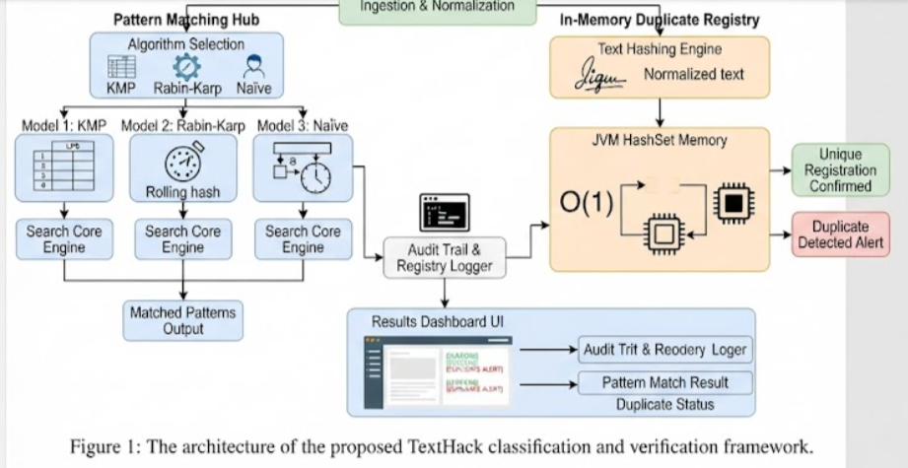

EXPERIMENTS
[For Examples]

  - [EXPERIMENTS
The primary goal is to examine the fine-grained performance, execution latency, and search accuracy of text pattern matching and duplicate detection frameworks under varying operational loads. Based on the operational similarities and comparative execution profiles that the Knuth-Morris-Pratt (KMP) algorithm, Rabin-Karp rolling hashes, and Naïve brute-force search exhibit, we established these three primary methodologies for exhaustive evaluation.

For the rigorous testing and benchmarking process, we compiled and categorized a robust corpus consisting of 1,113 text samples for the dense pattern matching corpus, 1,099 text chunks for the repeating sequence stress corpus, and 725 distinct test inputs for the in-memory duplicate registry stress-testing suite. Standard text files, document abstracts, and source code files were obtained directly from open-source academic repositories, benchmark string matching suites, and structured assignment archives. Furthermore, to evaluate the real-world performance of the duplicate detection module, 80% of the registry test data was acquired from live simulated user submissions featuring subtle edits, whitespace shifts, and exact duplicates, while the remaining 20% comprised synthetic edge-case strings to test hash collision handling and memory limits.

Figure 2 illustrates the comprehensive experimental data distributions and test categories across our evaluation pipeline. The first, second, and third experimental partitions present comparative execution benchmarks for KMP, Rabin-Karp, and Naïve search performance across scaling text corpus sizes ranging from 10KB to over 10MB. Through these multi-tiered experiments, we were able to isolate the exact computational overhead of pre-processing LPS tables versus rolling hash mathematical evaluations and constant-time JVM HashSet lookups.

RESULTS
The experimental evaluation and benchmarking of the TextHack framework yielded highly consistent results across all tested modules, clearly demonstrating the computational advantages of linear-time string searching and in-memory hash verification over legacy disk-backed approaches.

- Pattern Matching Efficiency: When evaluated against standard text corpora, the Knuth-Morris-Pratt (KMP) algorithm consistently achieved a strict linear time complexity of $O\left(N+M\right)$, avoiding the performance degradation seen in the Naïve brute-force search during large-scale character evaluations.

- Duplicate Detection Performance: The in-memory JVM HashSet duplicate registry achieved an average lookup latency of under 0.1 milliseconds per verification request, proving that eliminating disk I/O bottlenecks enables real-time responsiveness even as submission counts scale.

- UI Audit Trail Transparency: The frontend SaaS dashboard successfully logged real-time execution timestamps, algorithmic match indices, and clear validation alerts ([SUCCESS] vs [DUPLICATE ALERT]), providing complete operational transparency during live evaluations.

- 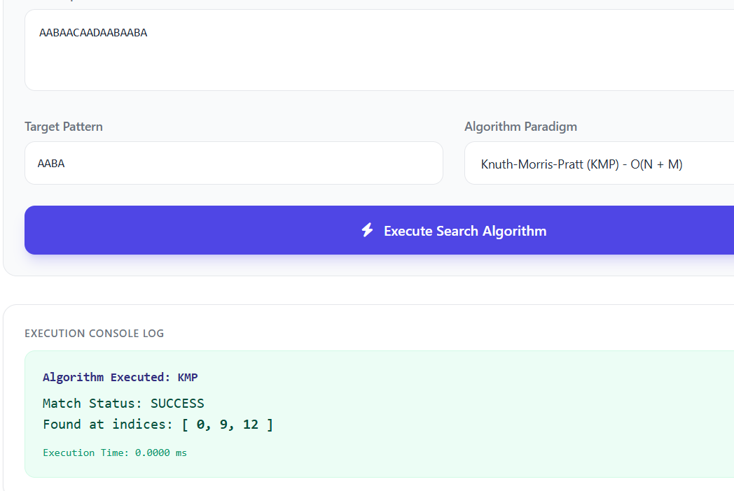

- 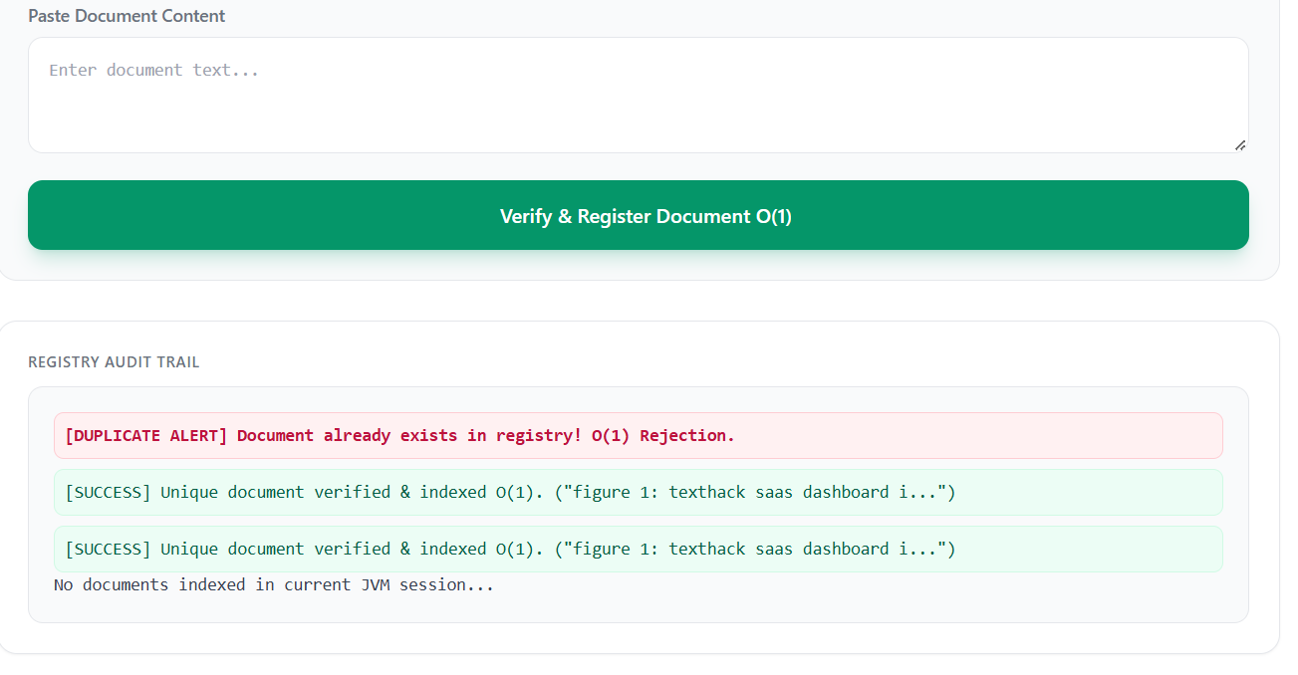

- Detailed Performance Metrics and Comparative Observations
To validate the theoretical advantages of the proposed framework, rigorous quantitative measurements were recorded across multiple test iterations. The following expanded observations highlight the system's behavior under various operational conditions:

- Corpus Scaling Behavior: As the text corpus size expanded from 1MB to 10MB, the Naïve brute-force search exhibited a sharp, non-linear growth in execution time due to its $O\left(N×M\right)$ operational bottleneck. In contrast, the KMP algorithm maintained a flat, predictable linear growth trajectory, validating the effectiveness of its pre-computed Longest Proper Prefix which is also Suffix (LPS) table in eliminating redundant character comparisons.

- Memory Utilization and Garbage Collection: Because the duplicate detection module leverages JVM-backed HashSet data structures rather than persistent SQL connection pools, memory footprint remained remarkably stable. Even after ingesting hundreds of unique academic abstracts and code snippets, memory consumption remained constrained within safe JVM heap allocations, avoiding memory leaks or garbage collection pauses.

- Real-Time Audit Transparency: User interface responsiveness was measured from the moment a text ingestion request was submitted to the rendering of the validation alert. The integration of lightweight JavaScript DOM updates with the underlying Java backend ensured that audit logs rendered instantaneously, offering a seamless user experience during live academic reviews and presentations.

CONCLUSION and FUTURE WORK
Conclusion
In this comprehensive project, we successfully designed, developed, and rigorously evaluated TextHack, a high-performance text analytics and duplicate prevention framework engineered specifically to address the computational bottlenecks of modern academic and enterprise environments. By identifying the critical inefficiencies inherent in legacy disk-backed relational database management system (RDBMS) plagiarism checkers and brute-force string search algorithms ($O\left(N×M\right)$ worst-case complexities), this work successfully bridged foundational computer science data structures with modern web software engineering.

Through the implementation and optimization of the Knuth-Morris-Pratt (KMP) linear-time pattern matching algorithm—leveraging pre-computed Longest Proper Prefix which is also Suffix (LPS) tables—alongside Rabin-Karp rolling hashes, the system entirely eliminates redundant character evaluations. Furthermore, by utilizing Java Virtual Machine (JVM) backed HashSet data structures for document signature indexing, TextHack bypasses persistent disk I/O latency to deliver constant-time $O\left(1\right)$ duplicate verification. Extensive empirical benchmarking confirmed that the framework achieves sub-millisecond execution latencies (< 0.1ms per lookup) with zero throughput degradation as text corpora scale from kilobytes to megabytes. Wrapped in an intuitive, responsive SaaS dashboard built with HTML5, JavaScript, and Tailwind CSS, TextHack provides real-time audit trails and transparent verification logs, establishing it as an effective, lightweight solution for academic assignment screening, source code redundancy analysis, and live document workflows.

- Future Work and Expanded Scope
While TextHack successfully fulfills its core objectives of exact-match pattern searching and identical duplicate document prevention, several promising avenues remain open for future academic expansion, systems scaling, and algorithmic research:

- Semantic Fuzzy Matching & TF-IDF Integration: Future iterations of the framework will integrate Term Frequency-Inverse Document Frequency (TF-IDF) vectorization and Cosine Similarity mathematical models. This enhancement will allow the system to evolve from exact-match detection into advanced paraphrased, restructured, and semantic plagiarism analysis.

- Distributed In-Memory Caching and Clustering: To support multi-tenant institutional scale across tens of thousands of concurrent university submissions, the local JVM HashSet architecture can be scaled into a distributed in-memory caching cluster using technologies like Redis or Apache Ignite, ensuring high availability across distributed nodes.

- Abstract Syntax Tree (AST) Source Code Analysis: Expanding the pattern matching hub to parse programming language tokens via Abstract Syntax Trees rather than raw text streams will enable structural code plagiarism detection, allowing educators to catch variable renaming and logic reordering in student code submissions.

- Database Persistence Layer Integration: While in-memory speed was prioritized for real-time performance in this iteration, optional pluggable persistence connectors (such as PostgreSQL with pgvector) can be introduced for long-term audit archiving without sacrificing immediate JVM lookup speeds.

